**User Based Usability Testing of Virtual Reality Environments**

**Serkan Kütük**

**Arda Poyraz**

**Umut Sarp Günüç**

**Berdan Şen**

**1) Methodology**

**1.A) Users**

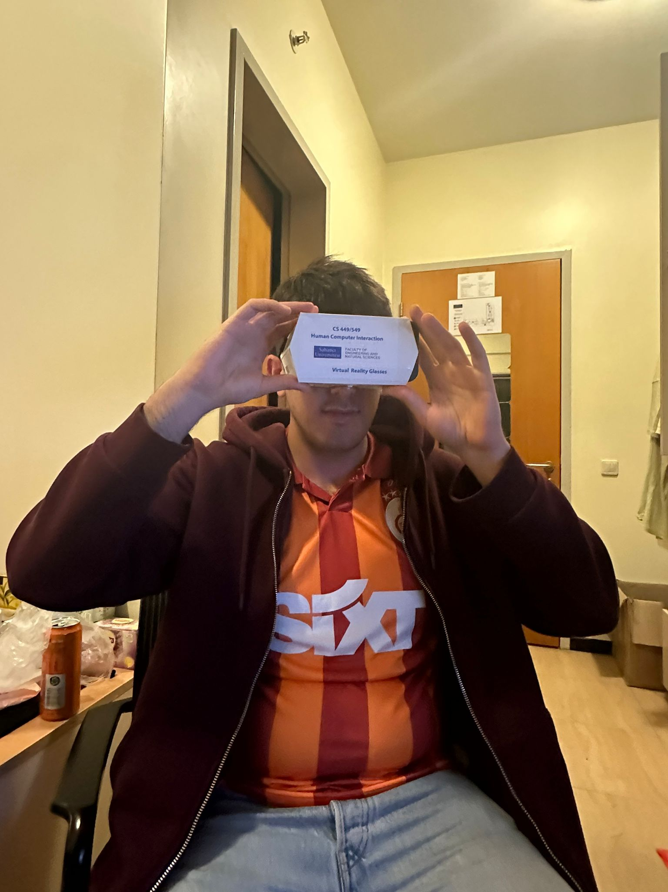

**Name:** X

**Age:** 24

**Gender:** Male

**Education Level:** Senior Student in Computer Science and Engineering at Sabancı University

**Background Information:** X is a senior student at Sabancı University in the Computer Science and Engineering department. Because of his department, he is good with technology. However, he is trying to reduce the time he spends on technology. As he stated, he does not have any social media accounts other than YouTube, which is his favorite application on both mobile and web. X generally uses computers and iPads as technological devices. Since he is an intern 3 days a week, he has to use the computer from 8 in the morning to 5 in the evening. He also uses his computer a lot to do his schoolwork. He usually uses his iPad to watch something on YouTube while eating. In his spare time, he likes to watch travel videos on YouTube.

**Expectations from Project:** Although he has been interested in technology, X has never had the chance to experience virtual reality (VR) before. He is excited about this project because it presents an opportunity for him to experience a VR environment.

**Technological Capabilities:**

* Due to his major and programming internship, X uses technological devices daily.
* He is well-acquainted with Android, IOS, and Microsoft devices.
* Aside from the arcade games he enjoyed as a child and the PlayStation he had the chance to play, his experience with technological devices is limited to mobile phones, tablets, and computers.

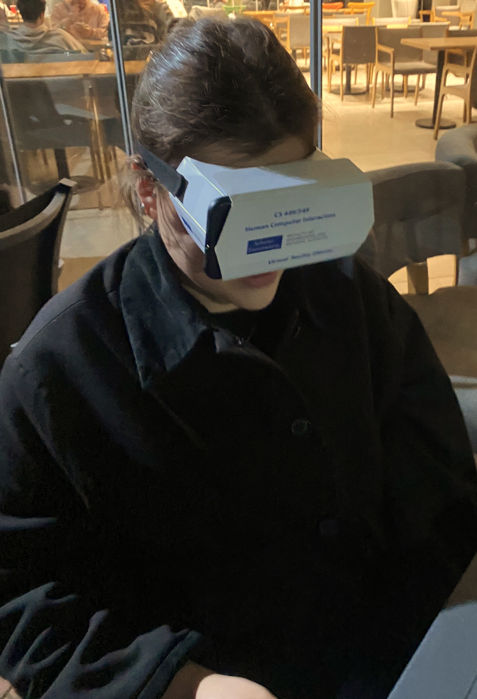

**Name:** Y

**Age:** 23

**Gender:** Female

**Education Level:** Senior Student in Industrial Engineering at Sabancı University

**Background Information:** Y is a senior Industrial Engineering student at Sabancı University. Her ability with technology is average; She can use various technological tools, but she does not consider herself too technology savvy. She has never experienced virtual reality (VR) before. Her favorite application and website is Instagram and her most used technological device is his phone. She loves playing the piano in his spare time. Also she sometimes play mobile games.

**Expectations from Project:** Although Y is not a technology enthusiast, she is curious about new developing technologies. She also especially wants to experience the VR glasses that she constantly sees on Instagram. Therefore, Y's expectation from this project is to experience playing games with VR glasses.

**Technological Capabilities:**

* Y is a last term student of Industrial Engineering at Sabancı University and her technological skills are above average due to her department and the courses she has taken.
* Y only plays simple games on her phone. Namely, she is in touch with technology but not games.

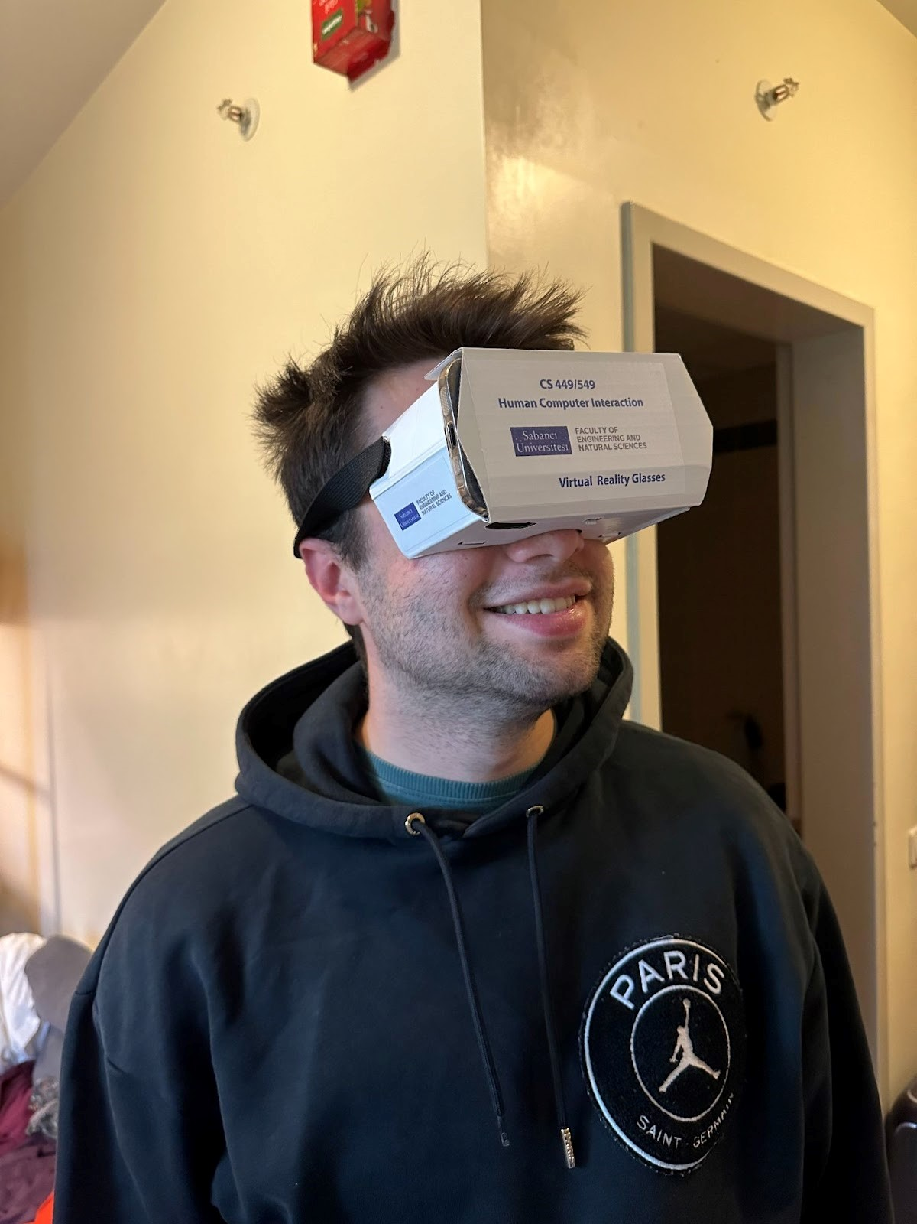

**Name:** Z

**Age:** 21

**Gender:** Male

**Education Level:** Junior Industrial Engineering Student at Sabancı University

**Background Information:** Z is a junior industrial engineering student at Sabancı, currently in his third year of education. He has been highly involed in technology since his childhood, that is one of the reasons he was chosen for this assignment. Nevertheless, he has no any VR experience yet. This will be his first VR experience. His favorite mobile app is Notion and his favorite website to scroll through is Twitter. In his free time, he occasionally spends most of his time with technological devices such as IPad, PS5, MacBook and IPhone. His prefZce for using mostly Apple products is because of the easiness of using Apple products in its eco-system.

**Expectations from Project:** Z’s expectations from this project is to get familiar with the VR technology since it is one of the few technological tools that he hasn’t tried yet.

**Technological Capabilities:**

* Because of his interest in technology, Z is very familiar with recent technologic developments and tools.
* He is very well informed about Apple products.
* 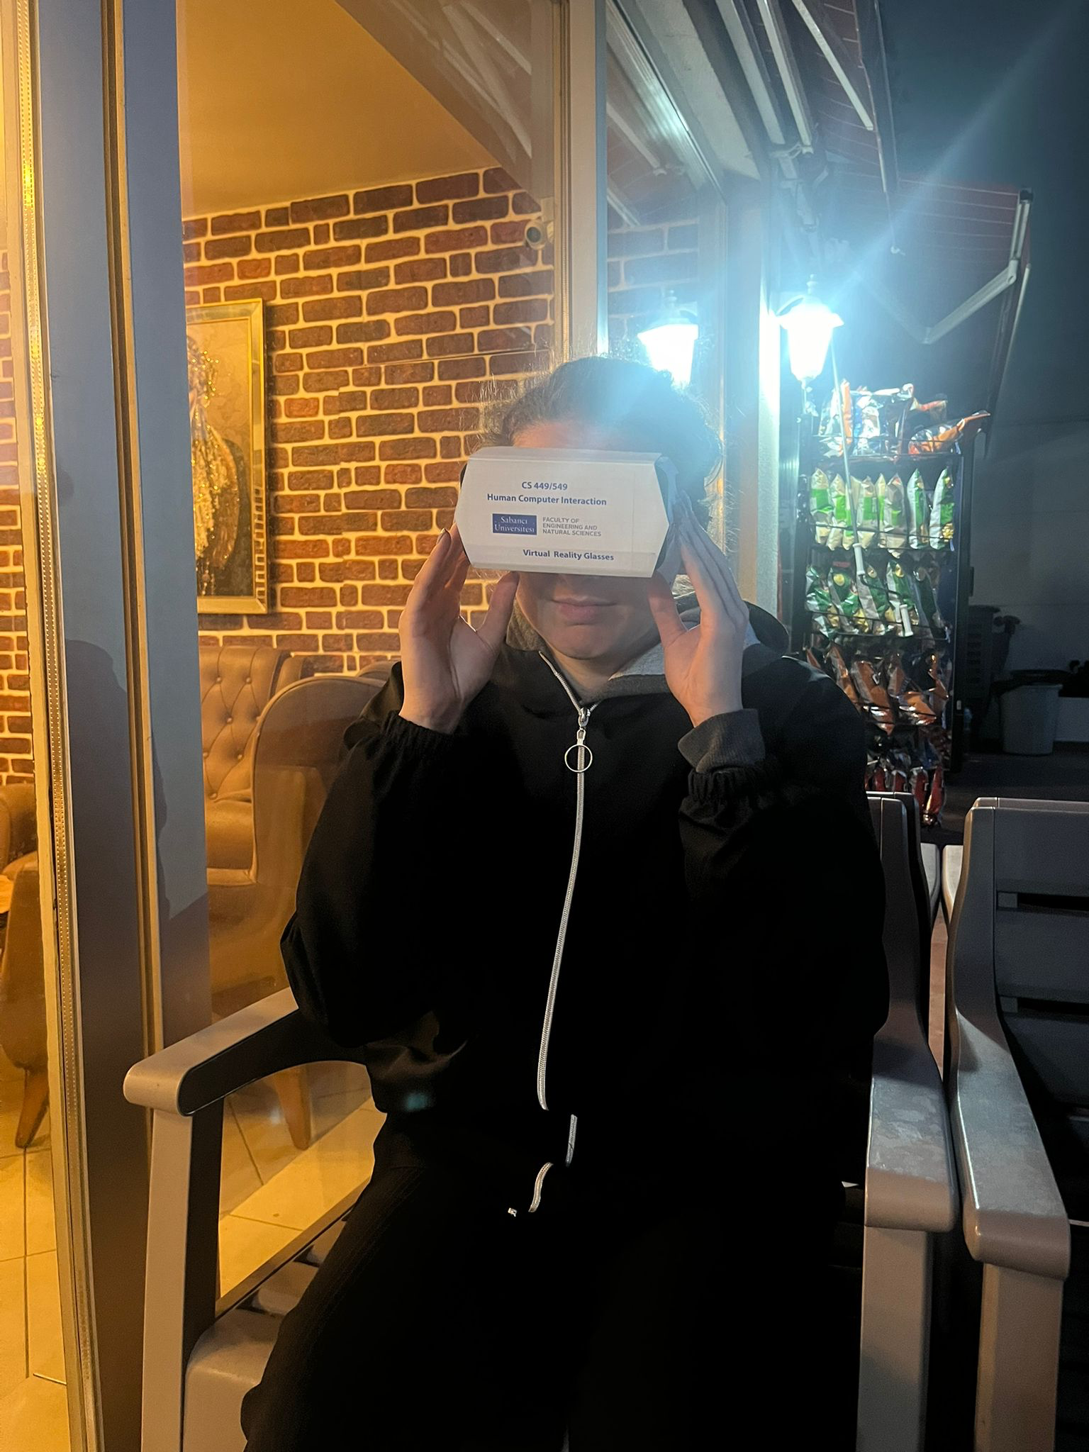He mostly plays games in his PS5. These games vary from old to new but he mostly plays recent video games.

**Name:** D

**Age:** 24

**Gender:** Female

**Education Level:** Graduate from Yildiz Technical University Chemistry Department

**Background Information:** D is currently working as Supply Chain Specialist in Pernod Ricard. She is interested in technology and frequently uses various technological devices and follow technological trends. She knows what virtual reality is, however she has not any experience with virtual reality application or tool. She is interested in games Her favourite mobile apps are Instagram and Twitter. When she use computer for personal time, she mostly spends her time in Netflix. She prefers using Macbook Air as computer and Iphone as mobile phone because of their features such as easy-to-use, lightweight and simple and good design of products. She spends her free time with diffZt activities such as watching series, spending time with her friends and doing sports.

**Expectations from Project:** D expects to gain experience in virtual reality field. She wants to experience how the game or application make her feel while interacting with it.

**Technological Capabilities:**

* Due to her education life and work life, she is experienced user of various technological devices with their various tools and applications.
* Not only mobile phone and computer, she is also experienced with games that she has experience with game consoles, PSP, Nintendo.

**1.B ) Test Procedure**

* Before the test:

We first set the goal of the test as identifying usability issues based on data collected from user’s interaction with the corresponding application. We determined the needed time for users to get adapted, understand and play the game. We selected 4 diffZt users that are not experienced with VR technologies and prepared questions to be asked during the test and after the test to analyze their experience with the application. We chose the mobile phone to be used in our tests and separated the task to group members that who will note user’s experiences while they are interacting, who will introduce the test to user. Who will watch their moves and who will conduct the test and check the time left. Based on these decisions, we introduced the test to users with all aspects, provided them a quiet environment and necessary tools to make the test comprehensive.

* During the test:

We first introduced the game, the device and steps to be followed to the test users at the beginning. Information is given to test users about the game and reminded them to think aloud in the process to make the test comprehensive. They were started to play the game’s first and second levels. We let them express their feelings and thoughts while playing the game and helped each other when they faced any issue. In their first minutes of playing, we did not navigate them through the process to measure and learn when they understand the context and what types of things they realized. We took notes of each of these aspects and experiences of test users. After a while, we helped them related to usage of application to increase their experience level and richness of our data collection. In that way, we collected all the natural and necessary informations needed. While users were playing, we tracked their movements and took notes of each expression related to process to analyze them later. Not only their comments and thoughts related to experience, we took notes related to their confusion, realization times of components and time took to complete the processes.

* After the test:

When test finishes, we started to ask already determined questions to users related to their experience and thoughts. This questions captured the data about their level of immersion feeling, any usability issues they realised, graphical experiences, visibility of system status, application’s easy-to-use, whether understanding how to use is easy or hard and any recommendations of the test users to improve the game. Then, we started to analyze quantitive and qualitative data collected from test users during the test and after the test. Based on their thoughts while interacting with the game and post-experience answers for the related questions enhanced the variety of data to analyze the application. Based on these thoughts, answers and SUS score of each user, we identified usability issues of the game and concluded with stating occurring problems, created ideas on how to solve and improve the parts mentioned by the test users and provided a comprehensive report related to usability issues of the game.

**1.C) Task Procedure**

1. Giving introduction about the test process, methods needed to apply and application itself. Providing test an environment that is proper for their experience.

2. Making users get adapted with the environment, headset and the application. Giving them a time to understand the context.

3. Let them introduce the menu of the game and information about menu panell.

4. Let them start playing level 1 (if necessary more than 1 time) and get adapted the game mechanics, how to play. Helping them learn how to play and collecting thoughts related to process of each player.

5. Let them start playing level 2 and wait until they complete tasks.

6. After they played the game, collecting necessary information before continuing with post-test interview. Started collecting data about game, their experience with all aspects.

7. Making a comprehensive interview with each of the test user to collect data.

8. To have a proper result from this data, analyze and understand the thoughts of the test user and categorize their concerns, ideas and thoughts. Then started to identify usability issues.

9.After analyzing the usability issues, reporting them in the conclusion part with suggestions.

**1.D) Context**

The main goal of this project is to evaluate the usability and immersive experience of a virtual reality (VR) game. By conducting detailed usability testing, the project aims to identify key factors that improve or reduce user engagement and satisfaction in the VR environment.

In order to satisfy this purpose, the usability testing for the virtual reality (VR) game "To the Earth’s Core VR" took place in a quiet setting to ensure participants could focus fully on the VR experience without distractions. The same mobile device was used for all tests, with the screen adjusted for a good view through the cardboard VR glasses.

Participants were informed about the testing process and the think-aloud protocol beforehand, which encouraged them to speak their thoughts and reactions while using the VR application. This provided valuable insights into their user experience. Keeping the testing environment and procedure consistent across all four sessions was important for collecting reliable and comparable data, which helped evaluate the usability and immersive quality of the VR game.

**1.E) Tool**

The mobile device used in the project is the iPhone 11. Running on iOS version 15.4.1, this device measures 2.98 inches in width and 5.94 inches in height. It boasts a Liquid Retina HD display with a resolution of 1792 by 828 pixels (Iphone 11 - Technical Specifications, 2024), delivering sharp and vibrant visuals for an enhanced user experience. The device has built-in stereo speakers. It aims to provide users with a more natural sound experience by spreading the sound over a wider area. As a result of the sounds coming from the left and right channels, the user feels the direction and depth of the sound better and gets an experience closer to real life. This sound system improves the VR experience. The iPhone 11 used in the project with both image and sound quality aspects offers users an optimal VR experience. Moreover, considering its size, it fits perfectly into the VR glasses used in the project. Additionally, its compact size makes it easy to fit into the VR glasses, which was used in the conduction of the test.

**2) Results**

**2.A) Data collected During the tests**

**User 1: X**

**Quantitative Data**

X played the game for 16.06 minutes in total. He played the first level 3 times and it took 8.33 minutes to pass this level. He played the second level for 7.31 minutes. He played the second level 4 times in total. He encountered monsters in 2 of them. But he couldn't complete level 2 successfully. He had to play the game twice in total to understand how it was played. Halfway through the second game, he was able to grasp how the game was played.

**Qualitative Data**

“It is impossible to keep track of your progress in the game. I understood that the indicators below and above are related to what I have collected in the game. But it is impossible to look at the indicators below while the game is in progress. I can't read the above indicators very well either.”

“The image quality is quite good. But since I'm focusing on the game, I don't think it will make much diffZce even if it's not good. The game draws you in. I feel like I'm playing Subway Surf with head movements.”

“At first, I thought I was racing with the car in front. I just realized that I'm controlling the vehicle based on the green focus point. When you collect the barrels, you hear a confirmation sound. Without it, I would have tried longer to understand the game.”

“It took some time to understand the game. But once you understand it, it's a fun game.”

“It's all good when I'm fighting the monster, but I can't see the number of rockets. I can't look down while playing the game (He is talking about the indicators below). I can only realize that my rocket is finished when the game gives me new rockets to collect. Also, while fighting, it is impossible to collect rockets. Congratulations to those who finished this level. I can't finish it.”

**User 2: Y**

**Quantitative Data**

Y played the first level 4 times and it took a total of 10.08 minutes to pass this level. Y understood how to play on her second try. She was able to pass the second level on her third try and it took a total of 6.14 minutes to finish the second level. In other words, breeze completed the first two parts of the game in 16.22 minutes in total.

**Qualitative Data**

"The image quality is not good, the characters at the beginning of the game look very blurry."

"Since the indicators are small and I cannot read the text fully, it is not clear at first glance what the buttons do."

"It is a difficult game to control and the experience is not much diffZt from other mobile games."

"You move it with your head, my user experience would be much better if there was eye tracking"

"I don't know what I'm doing, I wish there was a tutorial before I started the game"

**User 3: Z**

**Quantitative Data**

Z had played the game for about 10 minutes and 19 seconds. In his first try of playing, he managed to pass level 1 and move on to the next. It took about 5.14 minutes for him to finish the first level. After getting to level 2, he had some trouble with motion sickness because of the fast gameplay that the game had in level 2. It took him two tries to beat the boss in level 2. After his second playthrough on level 2, he managed to adapt to the game’s gameplay mechanics.

**Qualitative Data**

“Even though the game didn’t offer any tutorial or have any tips about what to do and when to do, I managed to understand what it was that I should do. It may be because of my gaming experience that goes a long way, nearly 15 years. Nevertheless, I would say that it would be very hard for someone who hasn’t played many games, especially someone that has no idea or understanding what VR is.”

“I would say that the quality of image is pretty poor. Maybe it has to do with the VR glasses or the game has some low graphic resolution. All in all, I would say that I didn’t fancy what I saw on the screen.”

“The hardest thing I have encountered is probably motion sickness. It was probably because my brain and my eyes wZ’t cooperating at the same time. It was too fast, especially in level 2, that my brain and eyes couldn’t keep up with the screen that I had a headache after playing the level 2 for the second time.”

“I had some trouble of understanding what it was that I should be doing during the boss part of the second level. There wZt any meaningful hints or indications of what to do. The only reason I managed to understand how to pass the boss was because I was constantly moving my head up and down and saw that there were rockets that I should be picking and firing.”

**User 4: D**

**Quantitative Data**

D spent 14 minutes and 4 seconds while understanding the process, playing the game, and trying to complete the necessary tasks. She first tried to learn the needed movements of the head to navigate through the menu of the game. This process took 2 minutes 30 seconds and got adapted, then she started to play the game. She spent 7 minutes and 20 seconds in the first level including restarting the game again and again. In this part, she adapted to the navigation and needed movements to play the game. While learning and playing, she followed think think-aloud principle and gave her thoughts related to each process. On average, completion of level 1 took 2 minutes for D and she tried level 1 for 4 times. After level 1, she tried to pass level 2 but she did not achieve it. She spent all the remaining time while trying to pass level 2, experienced the levels and menu completely but did not achieve the pass level 2.

**Qualitative Data**

“At the beginning, I did not realize how to move and start playing. I tried to discover how to control the menu panel and interactions.”

“I could not find the way to press buttons appearing on screen, then I realized I should wait on the button itself to continue to next screen or level”

“It is hard to follow and see the bars about collected gears and health”

“Why there is no guidance to user to teach user how to move while playing”

“I cannot understand which container should I pick up while playing red ones or blue ones?”

“I realized same as the menu panel, I should look for containers to collect them. It was hard to find”

“Graphics are not good enough, sometimes due to speed of the game and bad visuals, I cannot diffZtiate between containers”

**2.B) Post test interview (Qualitative data) results**

**User 1 : X**

**How can you describe the immersion level you experienced?**

“Since I couldn't understand what I was supposed to do in the game at first, the game didn't really draw me in very much. But after I figured out how to play it, I enjoyed it immensely and it was an engaging game. I had a lot of fun playing the game.”

**What are your thoughts about the usability of the application?**

“Although there are no major problems, I do not think that the application is very sufficient in terms of usability. There was one problem that stood out to me. That is absolutely impossible to read the indicators placed above and below. During the game, we try to collect barrels with head movements. I think it is almost impossible to control your fuel or health down below while moving the character with your head movements. Your head and eyes need to move independently of each other. Since this is not a behavior pattern we do often in our daily lives, it may take some time to get used to that. ”

**What are your thoughts related to the graphics and audio of the game?**

“I thought the graphics of the game were pretty good. I haven't had any problems with this. The sounds of the game were also pretty good. The confirmation sound when I collected the barrels helped me understand how to play the game.”

**Does the system provide the status of the processes explicitly, did you completely follow and understand the processes? What is the visibility of these components?**

“The system clearly shows your gas and health at the bottom, and the number of screws and rockets you have collected above. However, there are major problems with the appearance of these indicators. It is almost impossible to look at these indicators in the game. Therefore, this makes it very difficult to follow the progress. I think it is not possible to fully understand the process within the game.”

**Is the application easy to understand and easy to use?**

“It takes some time to understand the game at first. But I don't think this is a big problem. Ultimately, I understood how I should play on the second try. I think it is quite easy to understand and play. Only in the second level, it was very difficult to collect the rockets while fighting the monster. I think it's not about the system but about the difficulty of the level.”

**What are your recommendations to improve the game, test, and complete experience?**

“I think the phone can be vibrated when the character hits something. This both provides a stimulating interaction for the user and draws the player more into the game. Also, there definitely needs to be a solution to make the game easier to follow. If the indicators were in the center, it would be impossible to play the game. However, when they are in the corners, it becomes quite difficult to look at them in the game. Frankly, I don't know how we can find a solution. But a solution must definitely be offered for the indicators. The testing phase of the game was very enjoyable. There's nothing I can say about this.”

**User 2: Y**

**How can you describe the immersion level you experienced?**

"At first, I was trying to understand what it was because it was something I wasn't used to at all, and it didn't seem immersive, but later, after I got used to the game and the levels got harder, it became quite immersive."

**What are your thoughts about the usability of the application?**

"The application definitely has major shortcomings. It would have been much better if there had been a small tutorial at the beginning. Also, it was not possible for me to look at the side indicators in a game where I had to move my head. I think the usability of the application should be improved further."

**What are your thoughts related to the graphics and audio of the game?**

"The graphics of the game were not bad, only because it is played with VR glasses, there is a focusing problem, which blurs the images. The indicators and texts are much smaller than they should be. The sounds give me a feeling of satisfaction in the game, that is, I can say that the sounds of the game activate my emotions. But there was a very deep sound in it. It was a little disturbing."

**Does the system provide the status of the processes explicitly, did you completely follow and understand the processes? What is the visibility of these components?**

"I do not think that the system clearly gives the status of the processes. There were some indicators in the corners. But I couldn't quite understand what they were. I couldn't look at them while playing the game."

**Is the application easy to understand and easy to use?**

"This is very difficult until I get used to the game. It could have been a tutorial at the beginning. I didn't know exactly how to move in the game. Also, I thought the inventories we had to collect at the beginning of the game were obstacles. After my second playthrough, I realized what I had to do. The application was difficult to understand and use at first. But once you get used to it, it becomes comfortable."

**What are your recommendations to improve the game, test, and complete experience?**

“"First of all, there could be a tutorial video at the beginning of the game. Secondly, the focus point can be adjusted better. Thirdly, the difficulty level should be increased gradually instead of becoming too difficult at once as it was in level 2. It should be easier to look at the indicators on the side while playing the game.”

**User 3: Z**

**How can you describe the immersion level you experienced?**

“I felt high immersion while playing the game but this created some physical problems because game was too fast that made the game playing hard for me, I felt immersion but it was hard to follow with my eye and head the game.

**What are your thoughts about the usability of the application?**

“I am an experienced gamer that I can make guesses about where to click or look while interacting with menu and game itself. But there were problems that novice users can not know how to use the application and there was no guide for them. It was usable and responsive to my movements but it was hard to correlate with the game speed. While usability is high, it should be balanced with flow of the game.”

**What are your thoughts related to the graphics and audio of the game?**

“I did not like the graphics of the game that it was really hard for me distinguish between components. While trying to understand how to play, trying to balance my movements with game speed. It was hard to realize objects and diffZtiate between them. Audio part was good but graphics are not as good as audio provided.”

**Does the system provide the status of the processes explicitly, did you completely follow and understand the processes? What is the visibility of these components?**

“There were no guidance or progress indicator in the game. It was problematic because I am experienced game player that means I can predict the status of the gameplay or get adapted to menu panel to learn what buttons on the panel provides. But, lack of visuals that shows progress, steps or system status, It might be hard for novice players to get adapted and this situation can create confusion. Also while playing the game, it was hard to track collected item amount and health status. There were no progress bar in gameplay which creates uncertainity about how many percent of that level is passed while playing.”

**Is the application easy to understand and easy to use?**

“The game was very easy to play and understand. Only when I was fighting the monster in the last level, I didn't quite understand what I was supposed to do. But I solved it in a short time. I think I solved it so quickly because I'm good with games. If my mother or father played this game, they would have a hard time.”

**What are your recommendations to improve the game, test, and complete experience?**

“I think, game can flow slower to increase gaming experience. Also game should have better graphics that can create significant increase in the experience of the user. Also there should be guides for novice users to teach them how to use the panel and how to play the game. Lastly, there should be little instructions screen to teach user components of the game.”

**User 4: D**

**How can you describe the immersion level you experienced?**

“I felt high immersion while playing. Although there were parts that i hardly understood and figured out how to use, while playing the game even if it has fast flow of gameplay, i felt the immersion.”

**What are your thoughts about the usability of the application?**

“I think there were problems with the usability of the application. In menu panel, even if there are no instructions how to use there, after figuring out, it was easy to progress to desired parts. Game’s speed is so high that it was really hard to catch the necessary tools that decreases the usability.”

**What are your thoughts related to the graphics and audio of the game?**

“Graphics were not clear and high quality that decreases the experience level, user can not feel whether item is obtained or not. Sometimes, it was hard see the item to collect while playing because it was hard to diffZtiate objects due to low graphics.”

**Does the system provide the status of the processes explicitly, did you completely follow and understand the processes? What is the visibility of these components?**

“System does not provide progress bar or something like that while playing the game that confuse the user about the level progress. It was hard to see health and collection bars while playing the game, it was really hard to track these.”

**Is the application easy to understand and easy to use?**

“Actually it is easy to use but at the beginning, it was hard to understand how to move your character and get adapted with head movement to have complete control over the experience. Also, there were no guidance on how to use the menu and how to play the game”

**What are your recommendations to improve the game, test, and complete experience?**

“I think, user should follow their progress via progress bars while interacting with the system. Also locations of the health bar and collection bar should be replaced for seeing them easily by users. Also there should be guidance on how to use the application, how to play the game and maybe progress bar can be added to game screen that user can follow his/her progress. Graphics quality should be increased to make objects diffZtiation easy for user. In that way, experience will give more immersive experience.”

**2.C) Post-test questionnaire (Quantitative data) results.**

After hands-on experience with the VR, and interview questions, participants are asked to complete The System Usability Scale (SUS), which is a simple, ten-item questionnaire that enables to make a broad assessment of the usability of the system. SUS is designed to fulfill the demand for an easy-to-use and dependable tool and utilizes a Likert scale, where participants express their level of agreement or disagreement with a set of statements on a five-point scale (Brooke, 1995). The score for each item is combined to produce an overall usability rating, ranging from 0 to 100.

The SUS scores can be interpreted in a way that:

If the SUS score is less than 50, then the system is considered to be "Not acceptable", which means that the usability of the system is so poor, and it needs a series of serious improvements.

If the SUS score is between 50 and 70, then the system is considered to be "Marginal", which means that the usability of the system is okay, but still, it needs some improvements.

If the SUS score is more than 70, then the system is considered to be "Acceptable", which means that the usability of the system is satisfying, and it meets the general expectations of users.

**User-1) X**

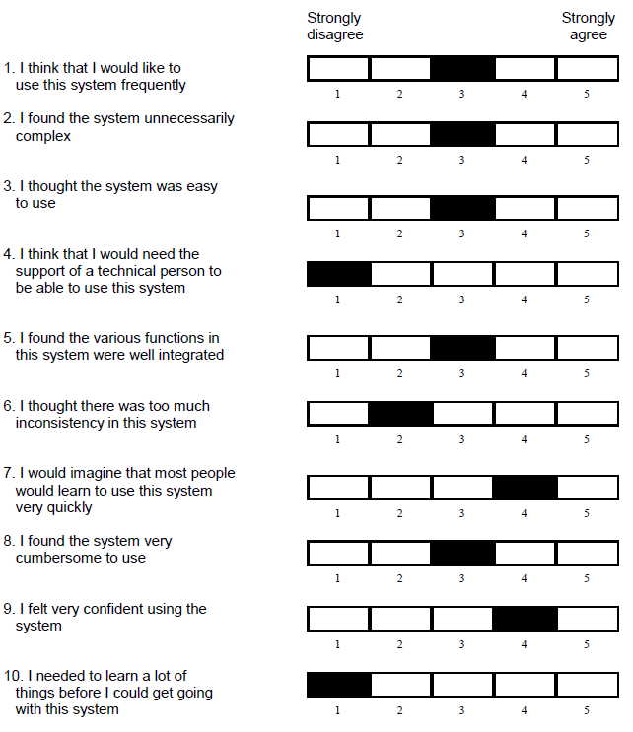

Figure 1

* The SUS score, determined by X, for the VR game is **67.5**. It is considered to be "**Marginal**", which means that the system is okay in general, however, it needs to be improved. The markings made by X can be seen in Figure 1.

**User-2) Y**

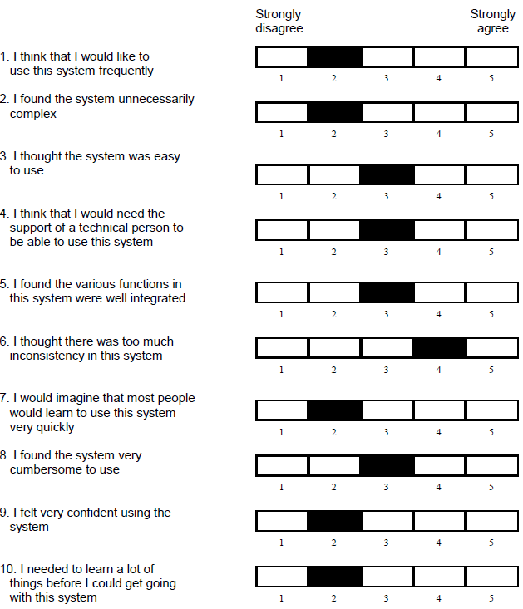

Figure 2

* Y's SUS score for the VR game is **45**. This score is considered **"Unacceptable"**, meaning that the usability of the system is poor and needs to be significantly improved. Her prefZces can be seen in Figure 2.

**User-3) Z**

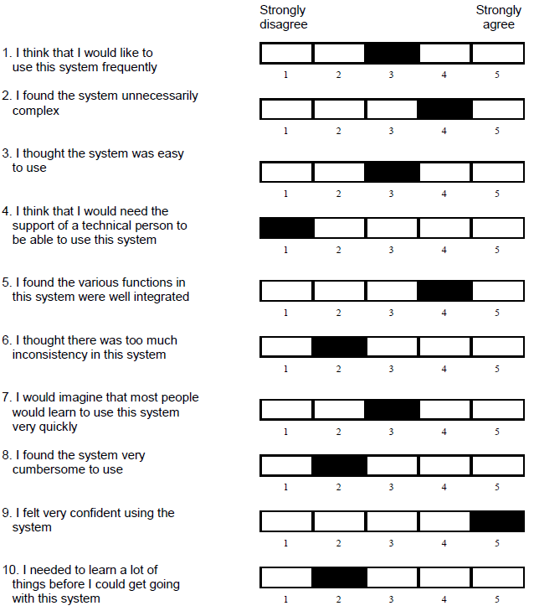

Figure 3

* The SUS score, determined by Z, for the VR game is **67.5**. It is considered to be "**Marginal**", which means that the system is okay in general, however, it needs to be improved. The markings made by Z can be seen in the Figure 3.

**User-4) D**

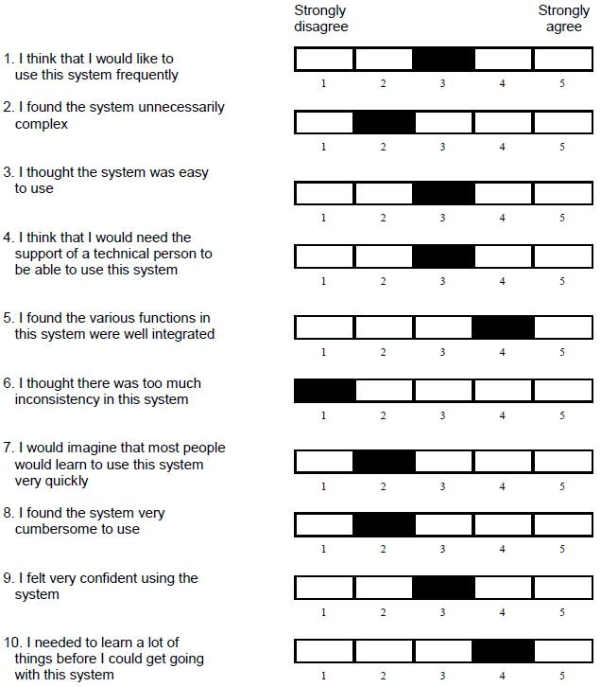

Figure 4

* D's SUS score for the VR game is **57.5**. It is considered to be **"Marginal"**, which means that even though the system is all right, there is a need for some developments. Also, it is important to note that his SUS score can be said to be almost at the border with being unacceptable.

**3) Discussion and Conclusion**

The data collected in the study were basically presented under three headings. First, four users were given VR glasses during the conduct of the test. Users, who were given preliminary information about the process, were asked to think out loud as part of the "Aloud protocol" during their experiences with VR glasses. During the VR experience, the words spoken by the users who shared their experiences aloud were classified as Quantitative and Qualitative data and used in the testing phase. After this stage, 6 previously prepared questions were asked to the users and their opinions on these questions were received. After the interview questions, the participants were asked to solve the System Usability Scale Test (SUS).

According to the data collected during the test and classified quantitatively, X spent a total of 16.06 minutes, Y 16.22 minutes, Z 10.19 minutes, and D 14.04 minutes for both levels. In other words, 4 participants experienced VR for an average of 14 minutes and 12 seconds. It took X 8 minutes and 33 seconds to pass the first level, including the initial scenes, Y's 10 minutes 8 seconds, Z's 4 minutes 2 seconds, and D's 7 minutes and 50 seconds. It took participants an average of 7 minutes and 48 seconds to complete the first level. For the second level, participants spent an average of 6 minutes and 24 seconds. However, it is worth noting that X, one of the participants, could not complete the second level. X, Y, and D had to play the first level twice to learn how the game was played. Z, on the other hand, understood how to play on his first try.

Based on the qualitative data, which is collected during tests, it is possible to say that all participants stated that the bars showing the progress of the game were very difficult to follow. All participants except X reported problems with graphics quality during the test. Users all expressed some criticism regarding the usability of the game. All participants stated that it was very difficult to control the bars and indicators that provide information about the progress of the game. Y and D stated that a short tutorial on how to play the game might be useful at the beginning. All participants except X expressed their problems with the graphics. While Z and D expressed great dissatisfaction with the graphics, the level of dissatisfaction was observed less in Y. All participants stated that it was very difficult to look at the indicators during the game. Therefore, they all stated that they were not aware of parameters such as remaining gas and lives during the game. Additionally, Z and D expressed their dissatisfaction because there is no bar in the game that shows how far they have come. Z stated that he is someone who likes to play games and said that he had no difficulty in understanding the game. X and Y said that it took some time to learn the game, but they did not have any problems after learning it. Regarding the development of the game, X said that interaction could be increased by introducing the vibration feature. Z and D stated that better image quality could increase the pleasure of playing games. Additionally, everyone except X stated that a short tutorial might be helpful at first. All participants agreed that the indicators and bars showing the flow of the game should be more visible and followable.

According to the System Usability Scale (SUS), the test results given to the application by users are as follows:

* X: 67.5 - "Marginal"
* Y: 45 - "Unacceptable"
* Z: 67.5 - "Marginal"
* D: 57.5 - "Unacceptable"

Considering these 4 participants, the average SUS score is 59.375. This puts the application in the "Marginal" category. In other words, the application offers a tolerable level of experience to its users. However, some improvements are required to increase the user experience.

**What are the usability issues ? Why ? How to improve them ?**

In our testing, based on feedback from users, we observed that there is a usability issue in the "To the Earth's Core VR" game. First of all, we received feedback from most users that there was a lack of training and guidance at the beginning of the game. While this caused users such as X and Y to have difficulty understanding the game at first, Z commented that the game was difficult to understand for those who had no previous gaming experience. Additionally, the game's image quality was criticized by many users; Y said that the characters were blurry, Z said that the poor graphics negatively affected the experience, and D stated that she had difficulty distinguishing objects due to the visuals. X, Y and D stated that they had difficulty tracking the progress and reading the indicators, they also stated that the buttons and text were too small or unclear, so they said that the game became confusing. Z experienced motion sickness in the second level due to the fast pace of the game, causing an uncomfortable situation for Z. In addition, control problems are another problem faced by users; Y stated that the game was difficult to control and that it would be a better experience with eye tracking, while D stated that she had difficulty navigating the menu and pressing the buttons. Voice feedback is another consideration, which Hakki says, while helpful in understanding certain aspects, needs to be improved for better intelligibility. Based on user feedback, we can observe that the game complicates the learning process, causes visual disturbances, and creates an overall confusing and less enjoyable user experience. Therefore, in order to increase the usability and interactivity of the game, it is necessary to provide clear guidance with tutorial videos, improve visual and sound quality, improve control mechanisms and offer a more fluid gaming experience. Also we need to add necessary progression bars or visuals to remind the users steps and status of the systems.

**Does it create an immersive experience? Did the users feel uncomfortable?**

Based on the data collected during the study, it seems the VR application doesn’t fully create an immersive experience for users. Here are a few reasons why:

Time Spent on the VR Experience: Participants spent diffZt amounts of time using the VR, averaging 14 minutes and 12 seconds. Some had to replay levels to understand the game, which might have affected their immersion.

User Feedback:

* Progress Bars and Indicators: All participants found it hard to follow the progress bars and indicators, which are key for staying engaged in the game.
* Graphics Quality: Except for X, everyone had problems with the graphics quality, which is crucial for making the VR environment feel real.
* Control Issues: Participants struggled to control the indicators and were often unaware of important details like remaining gas and lives, hurting their immersive experience.
* Progress Bar: Z and D specifically pointed out the absence of a progress bar as a major issue.

In conclusion, while the VR application has potential, it currently falls short in delivering a fully immersive experience. Addressing issues with graphics quality, control indicators, and user guidance could significantly enhance the overall user experience. Participants did feel uncomfortable due to issues with graphics quality, control difficulties, and a steep learning curve. Addressing these problems could help reduce discomfort and improve the overall user experience.

**Limitations of the study**

In this study, we have limited number of participants that took part in the test, this was one of the limitations we faced that decrease the richness of study’s result. Another limitation is we only have 1 vr application to use that actually we can not increase the existing one with another one to compare which can enhance the analysis scope and benefit readers while providing them good practices and bad practices of VR applications. Immersion and physical feelings can not be measured due to lack of tools and technologies that decrease the possibility of analyzing game’s effects on human’s feelings and body while interacting with it.

**How can this test be improved?**

To improve the test, several enhancements are required. First of all, the number of participants was only limited to 4 people. Conducting a study with a larger number of people can increase the reliability of the data, and it enables the study to make a broader generalization and representation. All participants were university students or graduates between the ages of 21-25. In other words, there was no equal distribution in terms of background. This is another issue that needs to be improved in the test. Working with participants from diffZt education levels and age groups will be beneficial for user testing to yield more accurate results. Applying iterative testing would have been extremely useful for this study. Improvements were made to the application in line with the feedback given and the participants could be tested again. It would be a very arduous and long process. However, the test would have yielded more efficiency, both in terms of the VR experience and the specific application used in the study. Finally, using techniques such as eye-tracking in the study could have increased the objectivity of the data collected. There would be objective data obtained directly from the participants. When they are interviewed, the objectivity of the data may be questioned. Therefore, increasing objective data would have been really useful in the context of this study.

# 

# **References**

Brooke, J. (1995). *SUS: A quick and dirty usability scale.*

*Iphone 11 - Technical Specifications*. (2024). Retrieved from Apple Support: https://support.apple.com/en-us/111865